Group Name (Group 5)

A proposal for (An on-Campus Map: Eagle Maps)

Members: Pearl Esezobor (10167217), Brian Perry (10193269), Riley Wilson (10195841), Cody Boudreaux (10164093)

**Project Background (Eagle Maps)**

Project Eagle Maps is an on-campus navigation application utilizing a graph-based data structure to model the layout of buildings, primarily class buildings, on campus. The purpose of this project is to assist users in locating and navigating to various campus buildings efficiently. This idea was inspired by the group's shared frustration with the current campus maps, which are often confusing and difficult to use. Our solution aims to provide a more intuitive system for finding classes, especially for new students.

The map will include a comprehensive list of buildings, with names and variable names corresponding to those found on student schedules (e.g., Bobby Chain Technology Center - TEC). This ensures users can easily cross-reference their schedules with the map.

**Project Functions and Features:**

Our application will have the following high-level features and functions:

1. **Shortest Path Finder:**
   * Implements the A* algorithm to calculate the shortest path between any two buildings on campus.
   * Displays walking distances and estimated travel times.
2. **Class Schedule Planner:**
   * Allows users to input their class schedule (with building names) and outputs optimized routes between classes.
   * Provides estimated time needed to move between buildings, helping students plan their day.
3. **Interactive Campus Map:**
   * Offers a visual representation of the campus.
   * Let users click on buildings to view their names, details, and nearby locations.
4. **Nearby Buildings Finder:**
   * Lists buildings close to a selected one.
   * Useful for finding nearby amenities or other class buildings.
5. **Dynamic Graph Management:**
   * Supports adding or removing buildings and paths dynamically.
   * Ensures the map stays accurate even if campus layouts change.

**Justification:**

**Navigating campus can be a stressful experience, particularly for freshmen unfamiliar with building locations. The current online campus maps are outdated and difficult to use. Our project, Eagle Maps, will provide a more efficient way to look up buildings, find direct routes, and plan class transitions.**

**This project is appropriately complex for a semester-long endeavor. It involves implementing a graph data structure, designing a user-friendly interface, and supporting CRUD (Create, Read, Update, Delete) operations for building and path data. The building information will be stored persistently using text files, and the entire application will be developed in C++.**

**With Eagle Maps, students will have a reliable tool to confidently navigate their campus.**

**Screenshots of our Program working to find the distance between 2 buildings on Campus, and the time it would take to walk between the 2.**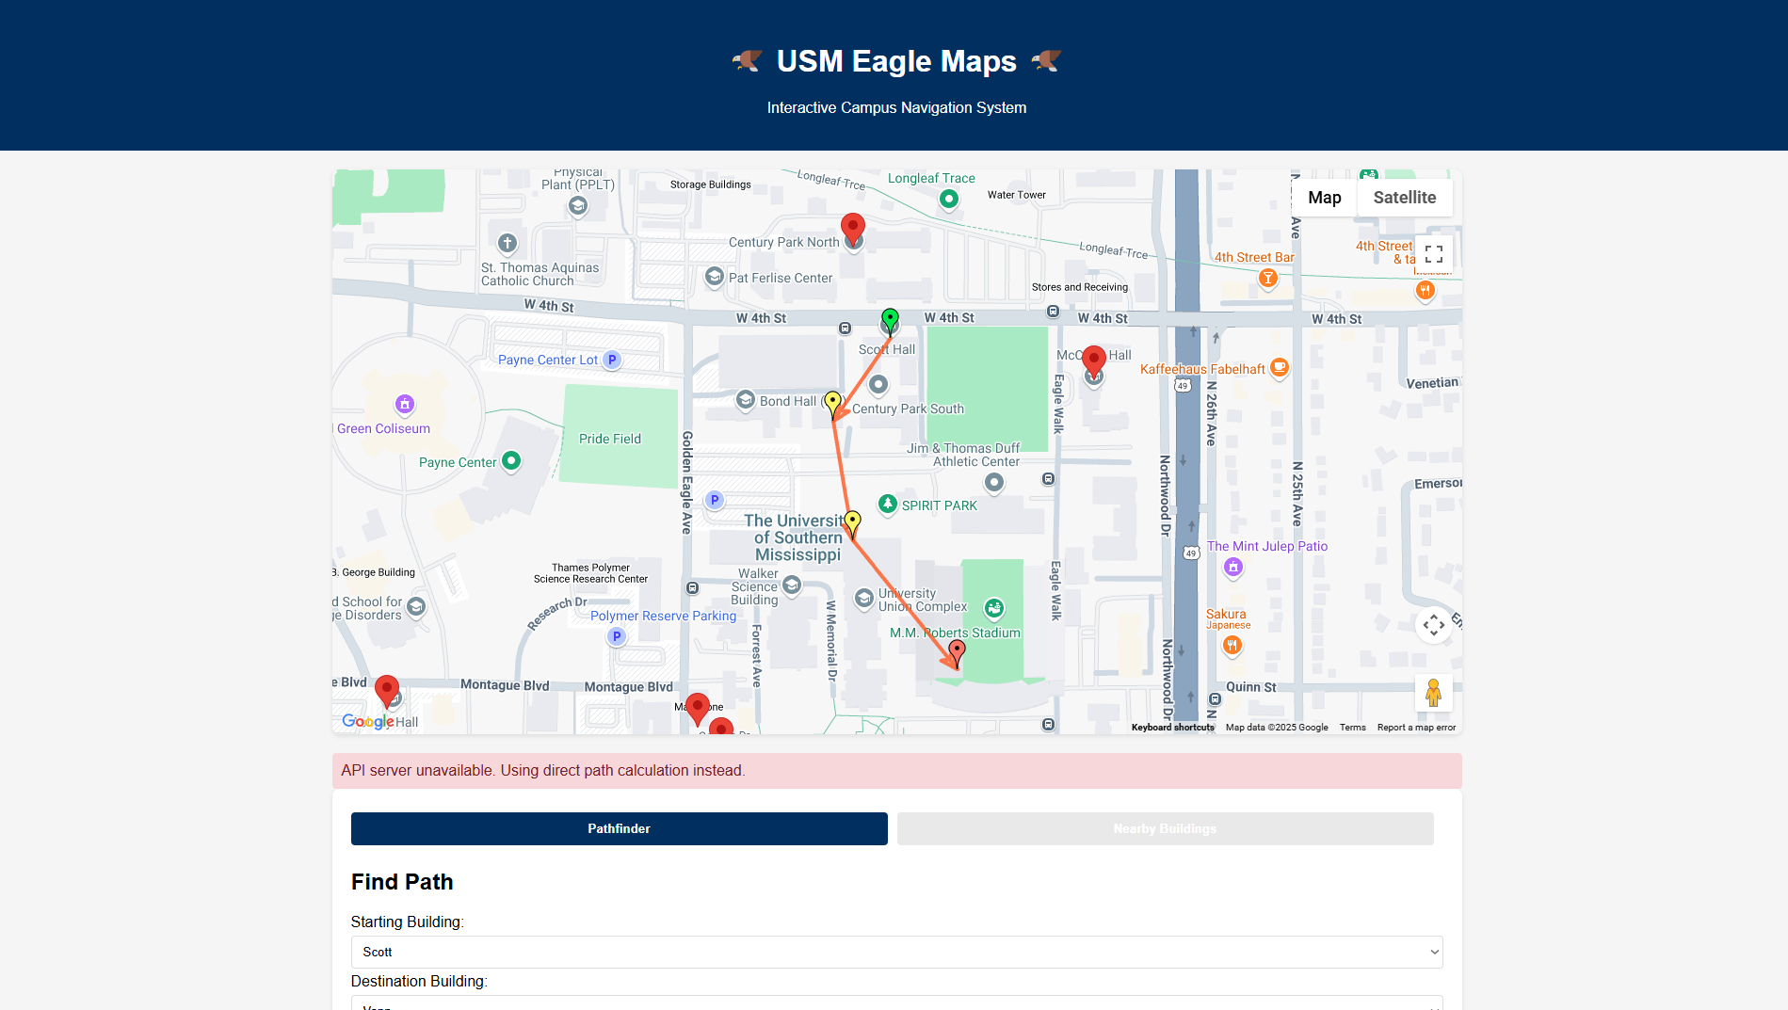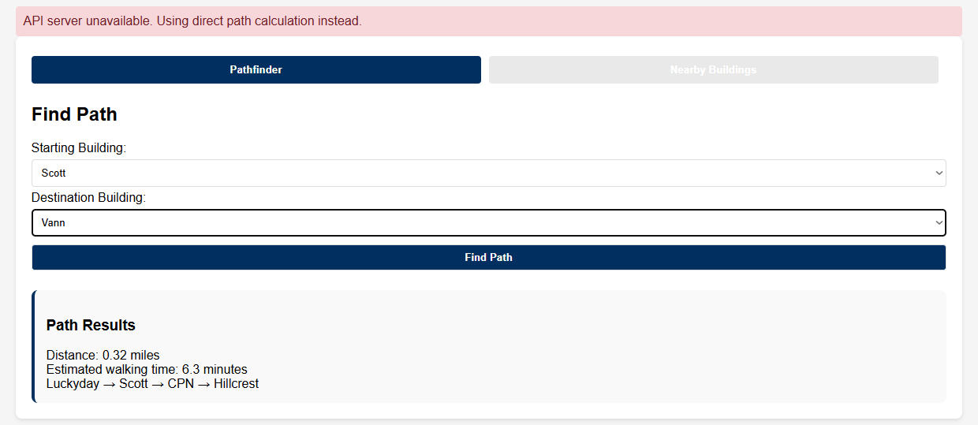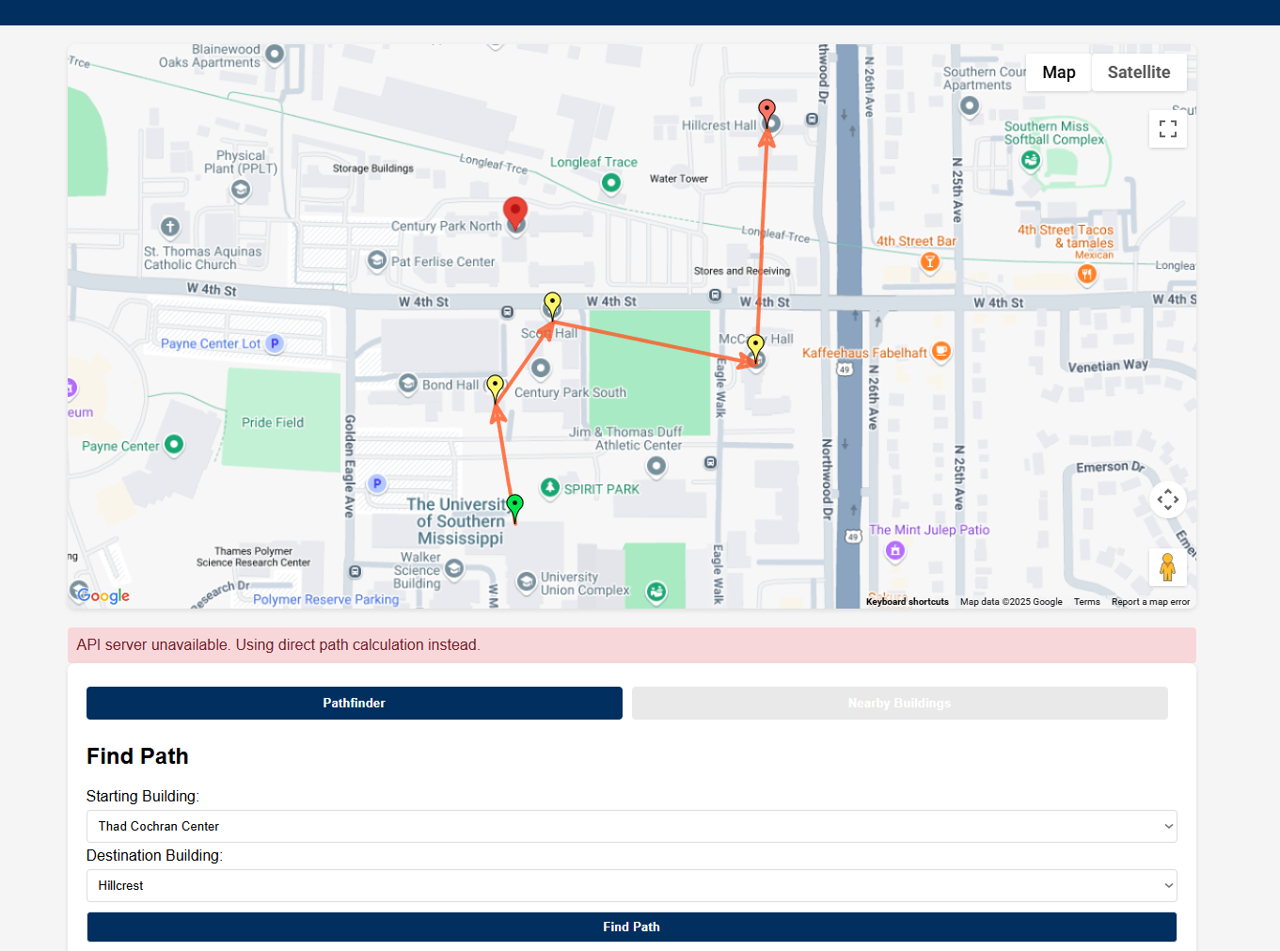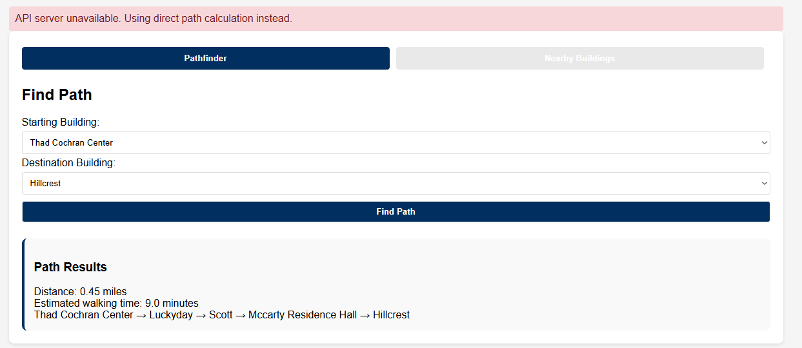

Here is our program finding nearby buildings relative to a selected building, the user is able to choose the maximum distance around said building, when searching for nearby buildings.

